Secure Web Application for Online Doctor Appointment System

Project Code

Project Advisor
Talha Randawa (internal &external)

Project Manager
Dr. Saad Razaq

Project Team
Ali Hassan BCSF18E013(Team leader)
Ahmed Hassan BSCF18E018(Team Member)

Submission Date

Table of Contents
1. Abstract 3
2. Background and Justification 3
3. Project Methodology 3
4. Project Scope 4
5. High level Project Plan 4
6. References 4

Abstract
Online doctor appointment is a smart web system, In which provide the login and registration for both patients and doctors. Doctor simply registered by filling the given required details like timings, fee, category, etc. After registration, doctors can easily login by entering username and password. Doctor can view the request of patients for booking if he takes the booking then status will be shown as booking confirmed to patient. Doctor can also able to view the feedback given by patient. Patient can also registered and login for book a doctor on the base of category and problem type of patient with the help of location. The search results will show the list of doctors matching patients necessary criteria and patient can select one of them and send a request the request will be gone to admin first then admin forward to doctor. If doctor is available he respond the admin then admin update the request and send confirmation message to patient. Patient can view the status from status tab and he will also get massage by mail about confirmation.

Background and Justification
In the current system the patient needs to visit the doctor for booking first or need to wait and the booking will be done physically by token so to keep everything is always a problem. In this system the doctors patients are carried to website will allow patients to be more flexible they can register and search for the doctors basing on the location the list of doctors will be shown and patient can book by choosing the time slots and the admin will check the booking so everything is computerized an done very easily which will save time.

3. Methodology

- Waterfall Model
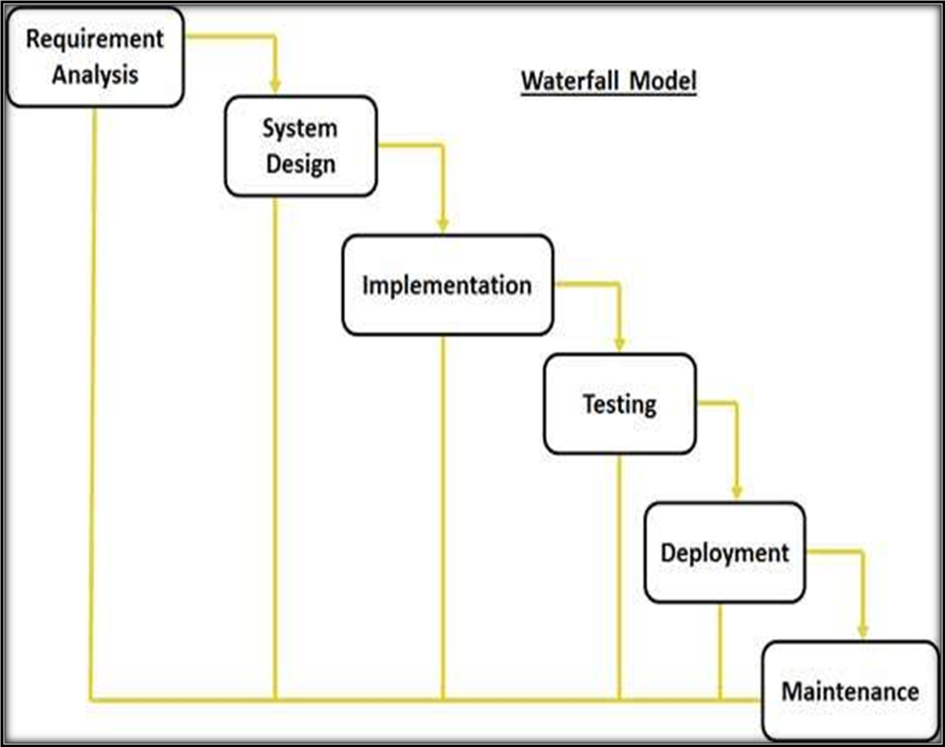
Fig. 3.0 Methodology

3.2 Justification of Methodology
Every software developed is different and requires a suitable SDLC approach to be followed based on the internal and external factors. Some situations where the use of Waterfall model is most appropriate are:
- Requirements are very well documented, clear and fixed.
- Product definition is stable.
- Technology is understood and is not dynamic.
- The project is short.
- Simple and easy to understand and use
- Easy to manage due to the rigidity of the model . each phase has specific deliverables and a review process.
- Phases are processed and completed one at a time.
- Easy to arrange tasks.

1.3 Description of Methodology
The sequential phases in Waterfall model are:
- Requirement Gathering and analysis: All possible requirements of the system to be developed are captured in this phase and documented in a requirement specification doc.
- System Design: The requirement specifications from first phase are studied in this phase and system design is prepared. System Design helps in specifying hardware and system requirements and also helps in defining overall system architecture.
- Implementation: With inputs from system design, the system is first developed in small programs called units, which are integrated in the next phase. Each unit is developed and tested for its functionality which is referred to as Unit Testing.
- Integration and Testing: All the units developed in the implementation phase are integrated into a system after testing of each unit. Post integration the entire system is tested for any faults and failures.
- Deployment of system: Once the functional and nonfunctional testing is done, the product is deployed in the customer environment or released into the market.
- Maintenance: There are some issues which come up in the client environment. To fix those issues patches are released. Also to enhance the product some better versions are released. Maintenance is done to deliver these changes in the customer environment.
All these phases are cascaded to each other in which progress is seen as flowing steadily downwards (like a waterfall) through the phases. The next phase is started only after the defined set of goals are achieved for previous phase and it is signed off, so the name "Waterfall Model". In this model phases do not overlap.
- Modules
The application has following modules
- Admin
- Doctor
- Patient
Admin
Admin can login with username and password in the admin section. He can able to view basic functionalities of admin. Admin can able to view registered doctos and patients. He can also manage the request system from both doctors and patients.
Doctor
Doctor need to be registered by giving the required details like skill, timing, fees etc. After registration he need to login and into the home screen and can view the some functionalities according to him. He can also view the patient request sended by admin and he can accept. He can view the feedback given by patients.
Patient
The patient needs both to be registered and login after logging on he can able to search for the doctor by giving the location and the problem. Base on the doctor confirmation the admin will check the appointment booking request and will send to mail that the booking for appointment is confirmed. He can also view in the status Tab and also give feedback on the base of doctor performance.

Project Scope
The scope of this project will focus on the patients and doctors who will use the system, to make the appointment through online service. This project will be implements for hospital or doctor clinic. The platform can be used by the doctor to manage the appointment for the patients through admin those who would like to do the appointment for the doctors through anytime and anywhere. Patient can also don’t need to wait in queued for appointment.

High level Project Plan
Activity | Oct-2021 | Nov-2021 | Dec-2021 | Jan-2022 | Feb-2022 | March-2022 | April-2022 | May-2022
Collection of Literature
Study of Literature
Analysis of proposed Scheme
Preparation of schemes/Model
Implementation of Schemes/Model
Analysis
Result Formulation
Final Write-up & FYP Report Submission

References
[1] Arthur Hylton III and Suresh Sankaran arayanan Application of Smart Agents in Hospital Appointment Planning System, International Journal of Computer Model and Engineering, Vol. 4, August 2012, pp. 625-630.
[2] Jagannath Aghav, Smita Sonawane, and Himanshu Bhambhlani “Health Track: Health Monitoring and Prognosis System using Wearable Sensors”, IEEE International Conference on Advances in Engineering & Technology Research 2014, pp. 1-5.
[3] YoeSyMey and Suresh Sankaranarayanan “Near Field Communication based Patient Appointment”, International Conference on Cloud and Ubiquitous Computing and Emerging Technologies, 2013, pp.98-103.
[4] RashmiA.Nimbalkar and R.A. Fadnavis “Domain Specific Search of Nearest Hospital and Healthcare Management System”, Recent Advances in Engineering and Computational Sciences (RAECS), 2014, pp.1-5.

